# Exercise 6: Flood Monitoring and Mapping

## Objectives

By the end of this exercise, you will be able to:

* Determine the likelihood of flooding by analyzing precipitation and streamflow over a region from Global Flood Monitoring System (GFMS).
* Evaluate flood intensity during a flood using GFMS
* Monitor surface inundation during and after a flood event by using MODIS-NRT and SAR images
* Determine flood impact by using SEDAC population and infrastructure data

## Case Study: Hurricane Matthew, North Carolina, October 7-9, 2016

**Highlights**[*Flooding in North Carolina from Hurricane Matthew Incurs $1.5 Billion in Damage*](http://weather.com/news/news/hurricane-matthew-north-carolina-update)

* Caused estimated $1.5 billion in damage to 100,000 homes, businesses, and government buildings
* More than 43 deaths have been reported along the East Coast, including at least 26 in North Carolina
* Several communities underwent a mandatory evacuation, including Pender County
* More than 2,000 people were rescued in over 600 rescue operations

**Federal Emergency Declared (FEMA)**

* North Carolina Hurricane Matthew (DR-4285)
* Incident Period: October 4-24, 2016
* Major disaster declaration October 10, 2016

## Outline

1. Rainfall and Flood Indicators
   1. Monitor Rainfall and Flooding Intensity Using GFMS
   2. Rainfall Time Series as a Flood Indicator
2. Examine Surface Inundation from MODIS NRT
3. Determine Population Density, Roads, and Landmarks
4. Examine SAR Images from Before and After Surface Inundation

## Part 1a: Monitor Rainfall and Flooding Intensity Using GFMS

* Go to <http://flood.umd.edu>
* Scroll down to **Rainfall (7 – day accum) [mm]**
* Using **Pan the map**, **Zoom in**,and **Zoom out**,zoom in on the state of North Carolina
* Under the map enter
  + **Start time:** 00Z07Oct2016
  + **End time:** 21Z11Oct2016
* Click on **Animate** and observe how the rainfall changes
* Note the maximum amount of 7-day accumulated rain observed during October 7-11, 2016
* Note the approximate area (in latitude and longitude) where heavy rainfall is observed

**Question**

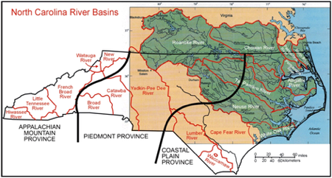

Image Credit: [Learn NC](http://www.learnnc.org/lp/media/uploads/2012/03/1_10.jpg)

1. Based on the GFMS rainfall maps, which river(s) are likely to flood?

* On the right side of the page, go to **Plot different variables** and select **Flood Detection (Depth)** from the drop-down menu and click **Plot**
* Repeat map animation steps for the **Flood Detection (Depth)** . Enter
* **Start time**: 00Z07Oct016
* **End time:** 21Z11Oct2016
* Click on **Animate** and observe how the flood intensity is changing

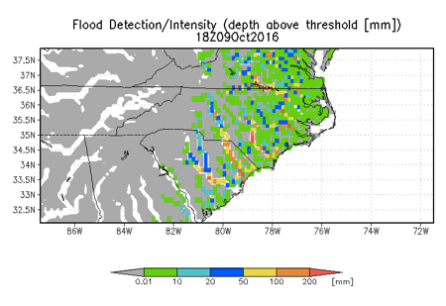

**Questions**

1. Based on the rainfall animation, did the rivers you thought would flood show high flood detection depth?
2. Which river(s) had maximum intensity flooding? Note the date, time and maximum flood depth observed.
3. What do the green shaded areas outside the river channel represent?

## Part 1b: Rainfall Time Series as a Flood Indicator

* Under Plot different variable select Rainfall (3-day) from the drop-down menu
* Under Plot time series for an individual point (lat, lon): enter
  + T1: 00Z07Oct2016
  + T2: 21Z11Oct2016
* Zoom in on the map close enough to individual pixels
* Enter lat –lon: 34.78 and -78.86. This is close to Fayetteville, NC which was heavily flooded
* Click on See Time Series
* Save the time series on your computer by dragging or right clicking the image with your mouse
* Repeat the same time series calculation for Flood detection (Depth)
* Examine both time series and note the period when accumulated rainfall is rising. Also examine the flooding detection depth and see if you can deduce the flood episode from the rainfall time series.

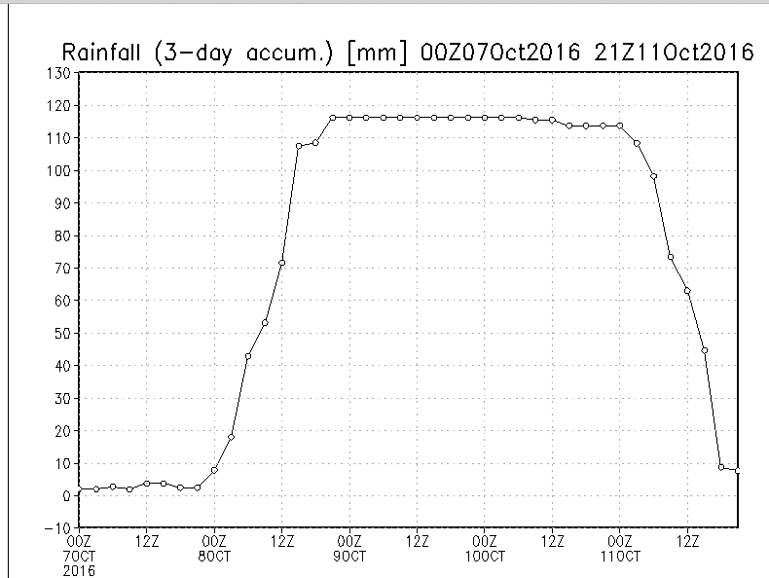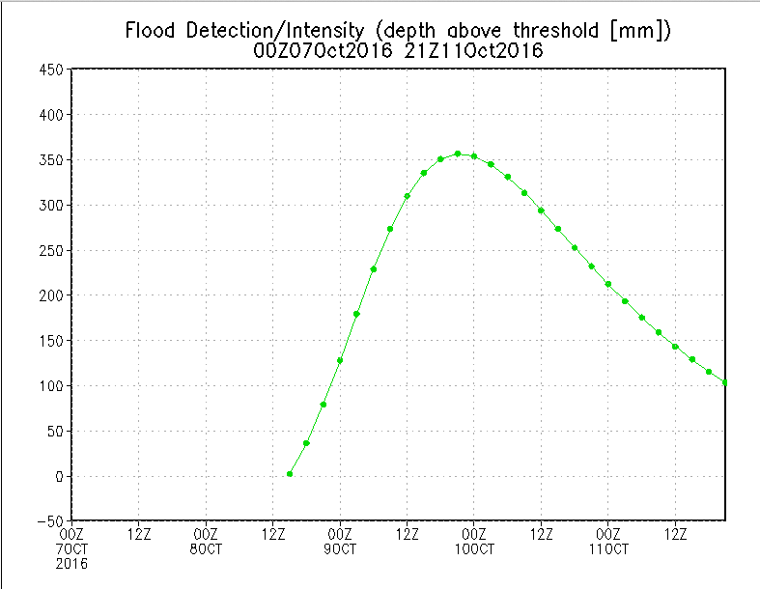

## Part 2: Examine Surface Inundation from MODIS NRT

* Go to the MODIS Near Real-Time (NRT) Global Flood Mapping Portal: <http://oas.gsfc.nasa.gov/floodmap/>
* On the left side of the page, click on the **Plus icon** next to **Data Viewer**
* 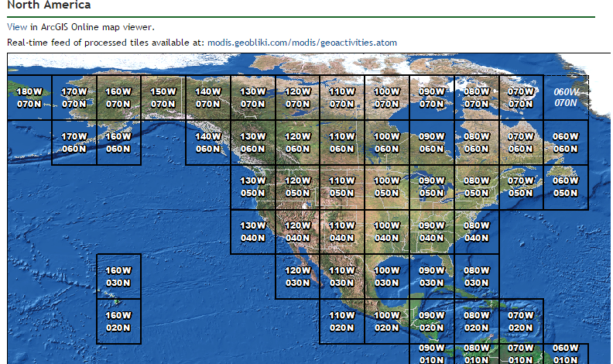Click on **North America**
* Click on the square **80W and 040N**
* From the top bar select **14 Day Composite**
* Using the calendar in the top upper left, select [October 8, 2016](https://floodmap.modaps.eosdis.nasa.gov/getTile.php?location=080W040N&day=283&year=2016&product=14)

**Do you see any inundation where GFMS shows high rainfall?**

* You can also use the direction arrows 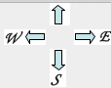 to explore surrounding grids to see if there is surface inundation present
* Next, for **14 Day Composite,** examine how the inundation maps change from October 8, 2016 – January 11, 2017, in the 80W 040N grid
* Click on the maps to zoom-in and see the surface inundation
* **Download the MODIS Flood Water** shapefile for the 80W, 040N grid using the 14-day composite for October 11, 2016.

## Part 3: Determine Population Density, Roads, and Landmarks

* 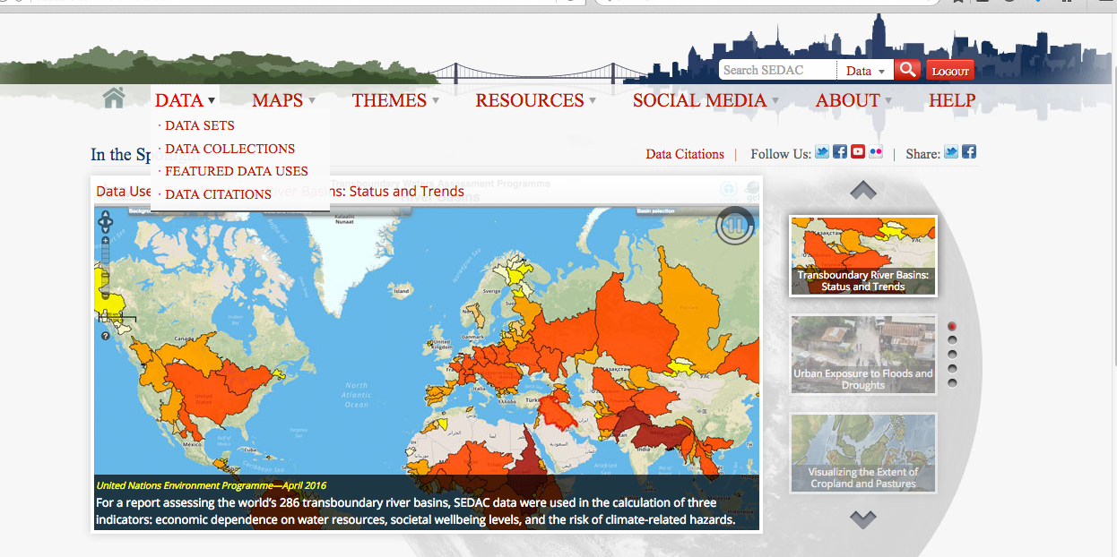Go to the SEDAC website: <http://sedac.ciesin.columbia.edu/>
* **Login** using your previously created SEDAC username and password
* Click on the **Data** tab and select **Data Sets**
* 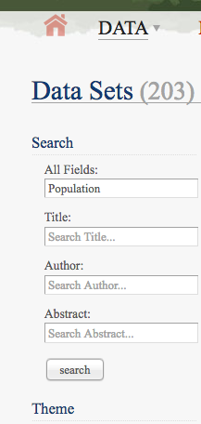Type **population** in the **All Fields** search box
* Download the **UN-Adjusted Population Count, v4 (2000, 2005, 2010, 2015, 2020) dataset**
* Go back to the **Data Sets** tab and type in **roads** to the **All Fields** search box
* Download **Global Roads Open Access Data Set (gROADS)** **v1** for the Americas
* Import both of these products into QGIS
* Import the previously downloaded MODIS Flood Water dataset
* Change the layer properties (color and transparency) for each layer
* Visually inspect the areas near and around the flood water by zooming in
* Optional: you can download MODIS flood water shapefiles for multiple days and see how long the inundation lasts on the surface

**Questions**

1. Are there highly populated areas experiencing flooding?
2. Are there roads that may be under water?
3. Discussion: Based on the flood density analysis in Part 1and the MODIS inundation map, where should your relief efforts be focused? Why?

## Part 4: Examine SAR Images for Before and After Surface Inundation

* Go to the Alaska Satellite Facility Sentinel Data Portal: <https://vertex.daac.asf.alaska.edu/>
* Under the **Geographic Region** section on the left, enter the following coordinates: -86.35, 32.88, -81.39, 30.98, -74.93, 35.35, -79.98, 38.07, -86.35, 32.88
* Expand **Date** and enter your start and end dates:
* Start Date: 2016-10-01
* End Date: 2016-10-31
* Expand **Dataset** and make sure **Sentinel 1-B** and **Sentinel-1A** are both checked
* 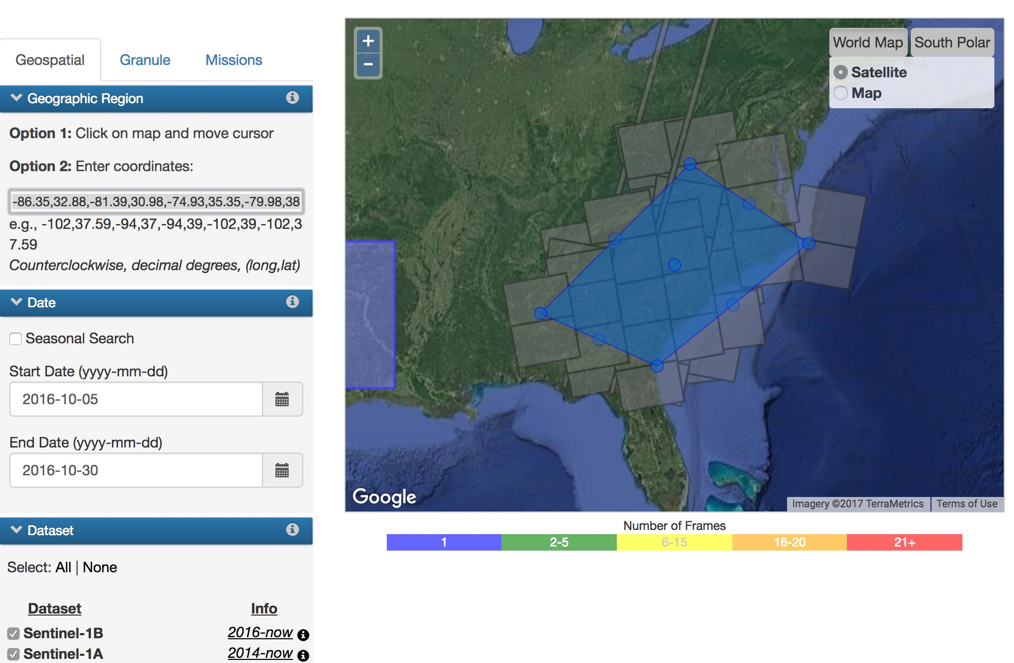Click **Search**
* 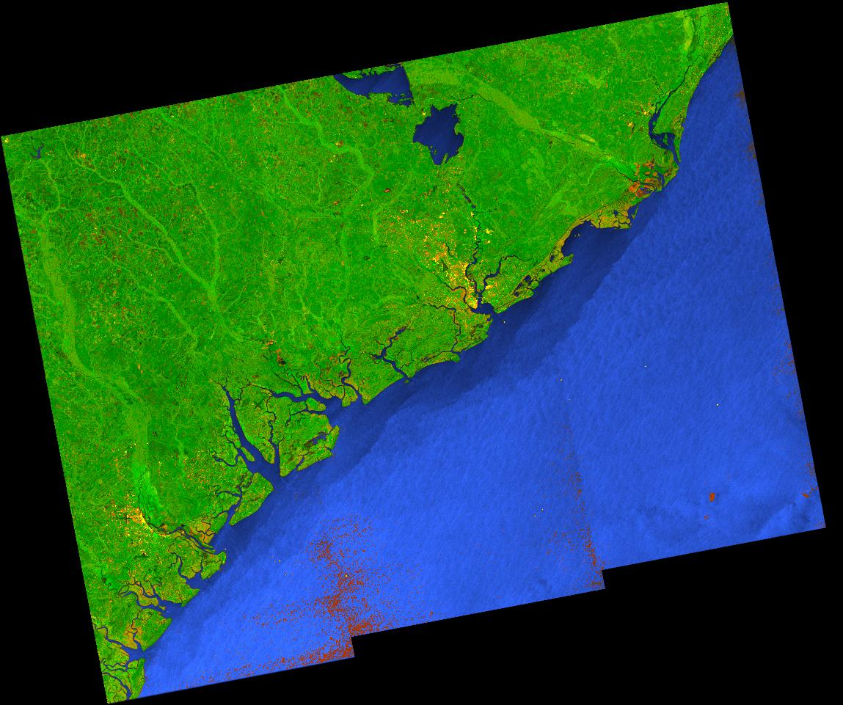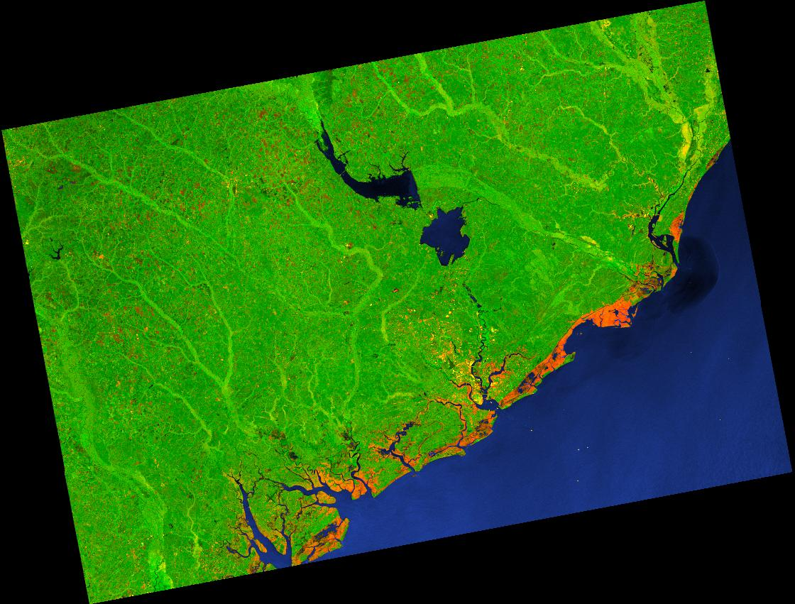Click on the map to draw a square around the area of interest. You can click the corners to change the shape of the polygon.
* Download the following file from before the hurricane on October 4, 2016: S1A_IW_GRDH_1SDV_20161004T232124_20161004T232153_013347_015494_859D
* 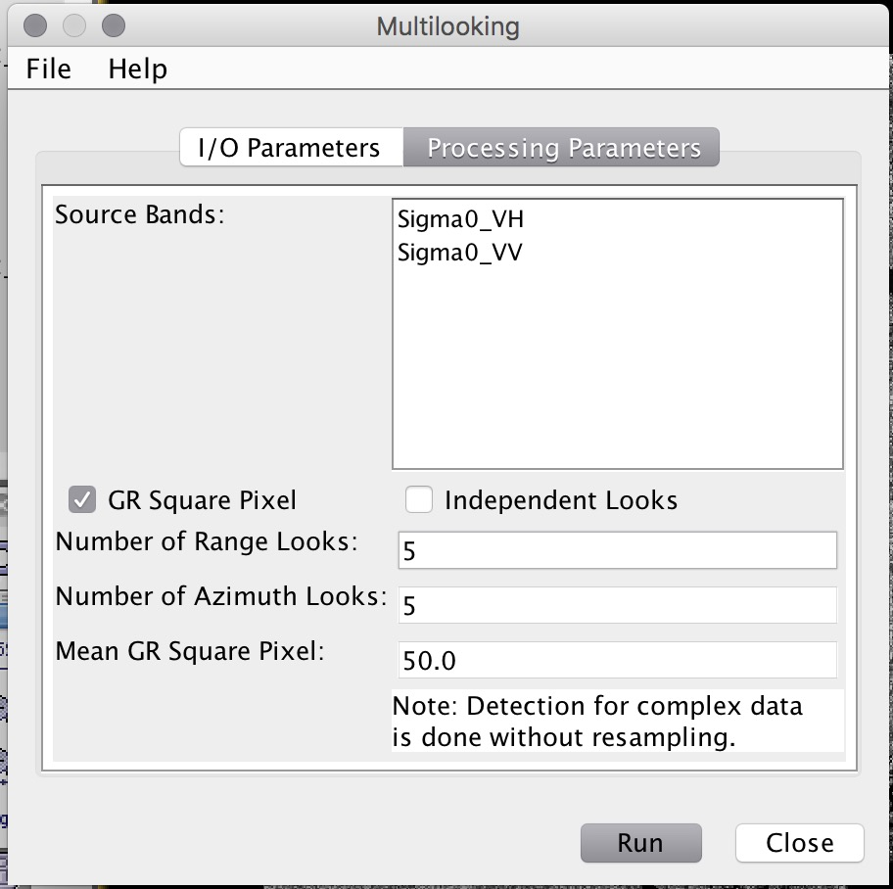Download the following file from after the hurricane on October 16, 2016: S1A_IW_GRDH_1SDV_20161016T232134_20161016T232159_013522_015A21_DDFC
* In the Sentinel Toolbox, run the radiometric calibration on each file by clicking on **Radar** in the top menu, then clicking **Radiometric**, and **Calibrate**
* Then run the multilook function (this gets rids of some of the speckle noise) by clicking on **Radar** in the top menu and selecting **Multilooking**
* 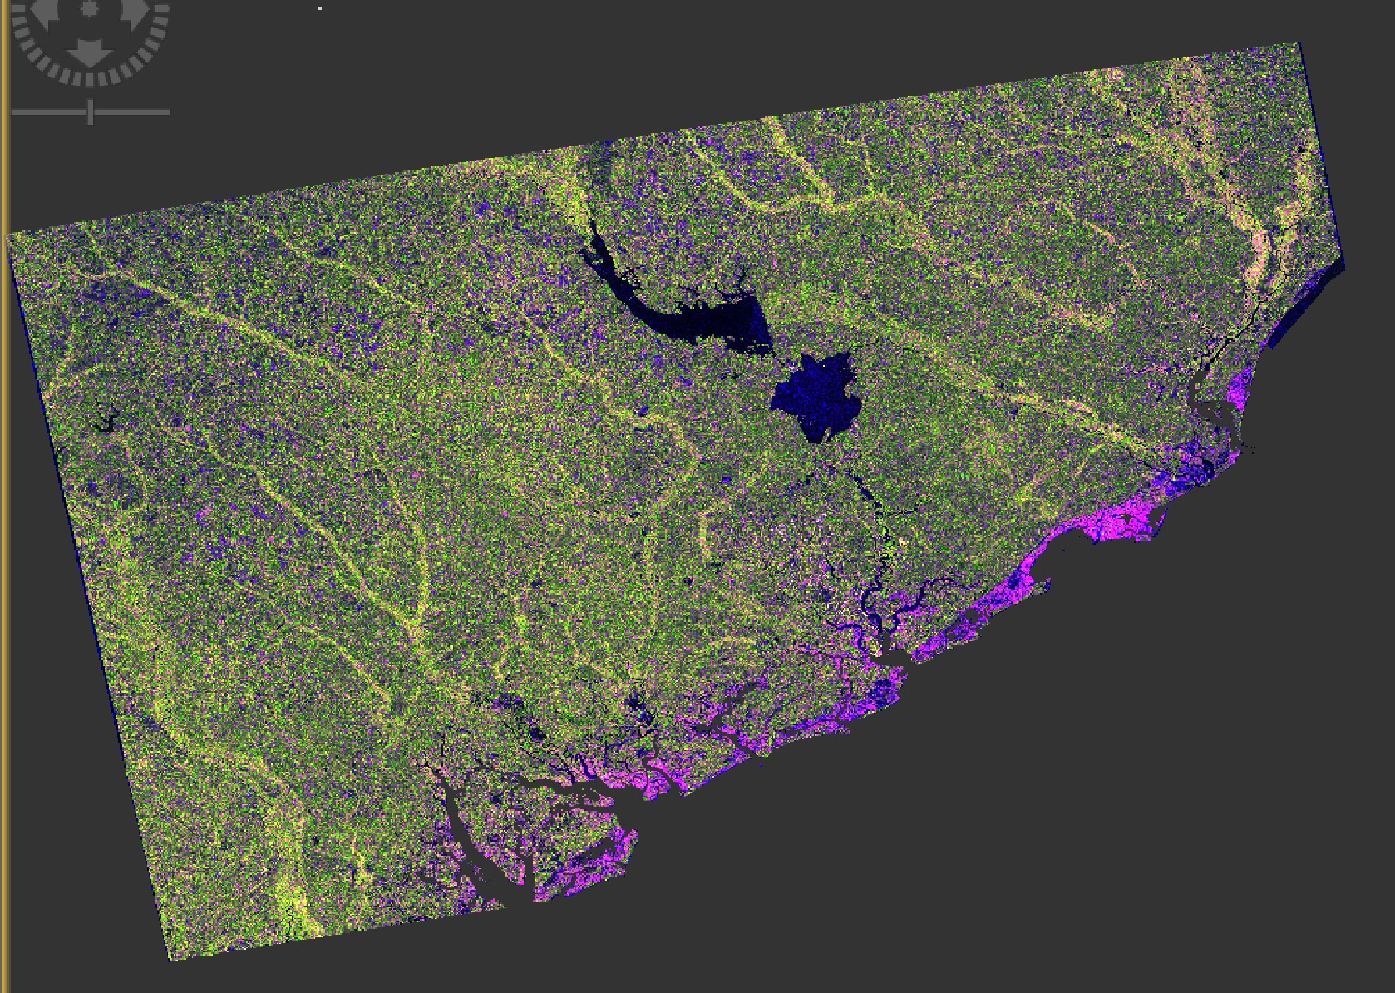Run the terrain correction on each file by clicking on **Radar** > **Terrain Correction** > **Range-Doppler Terrain Correction**
* Coregister the files by going to **Radar** > **Coregistration** and selecting **Coregistration**
* Create an RGB from the coregistered files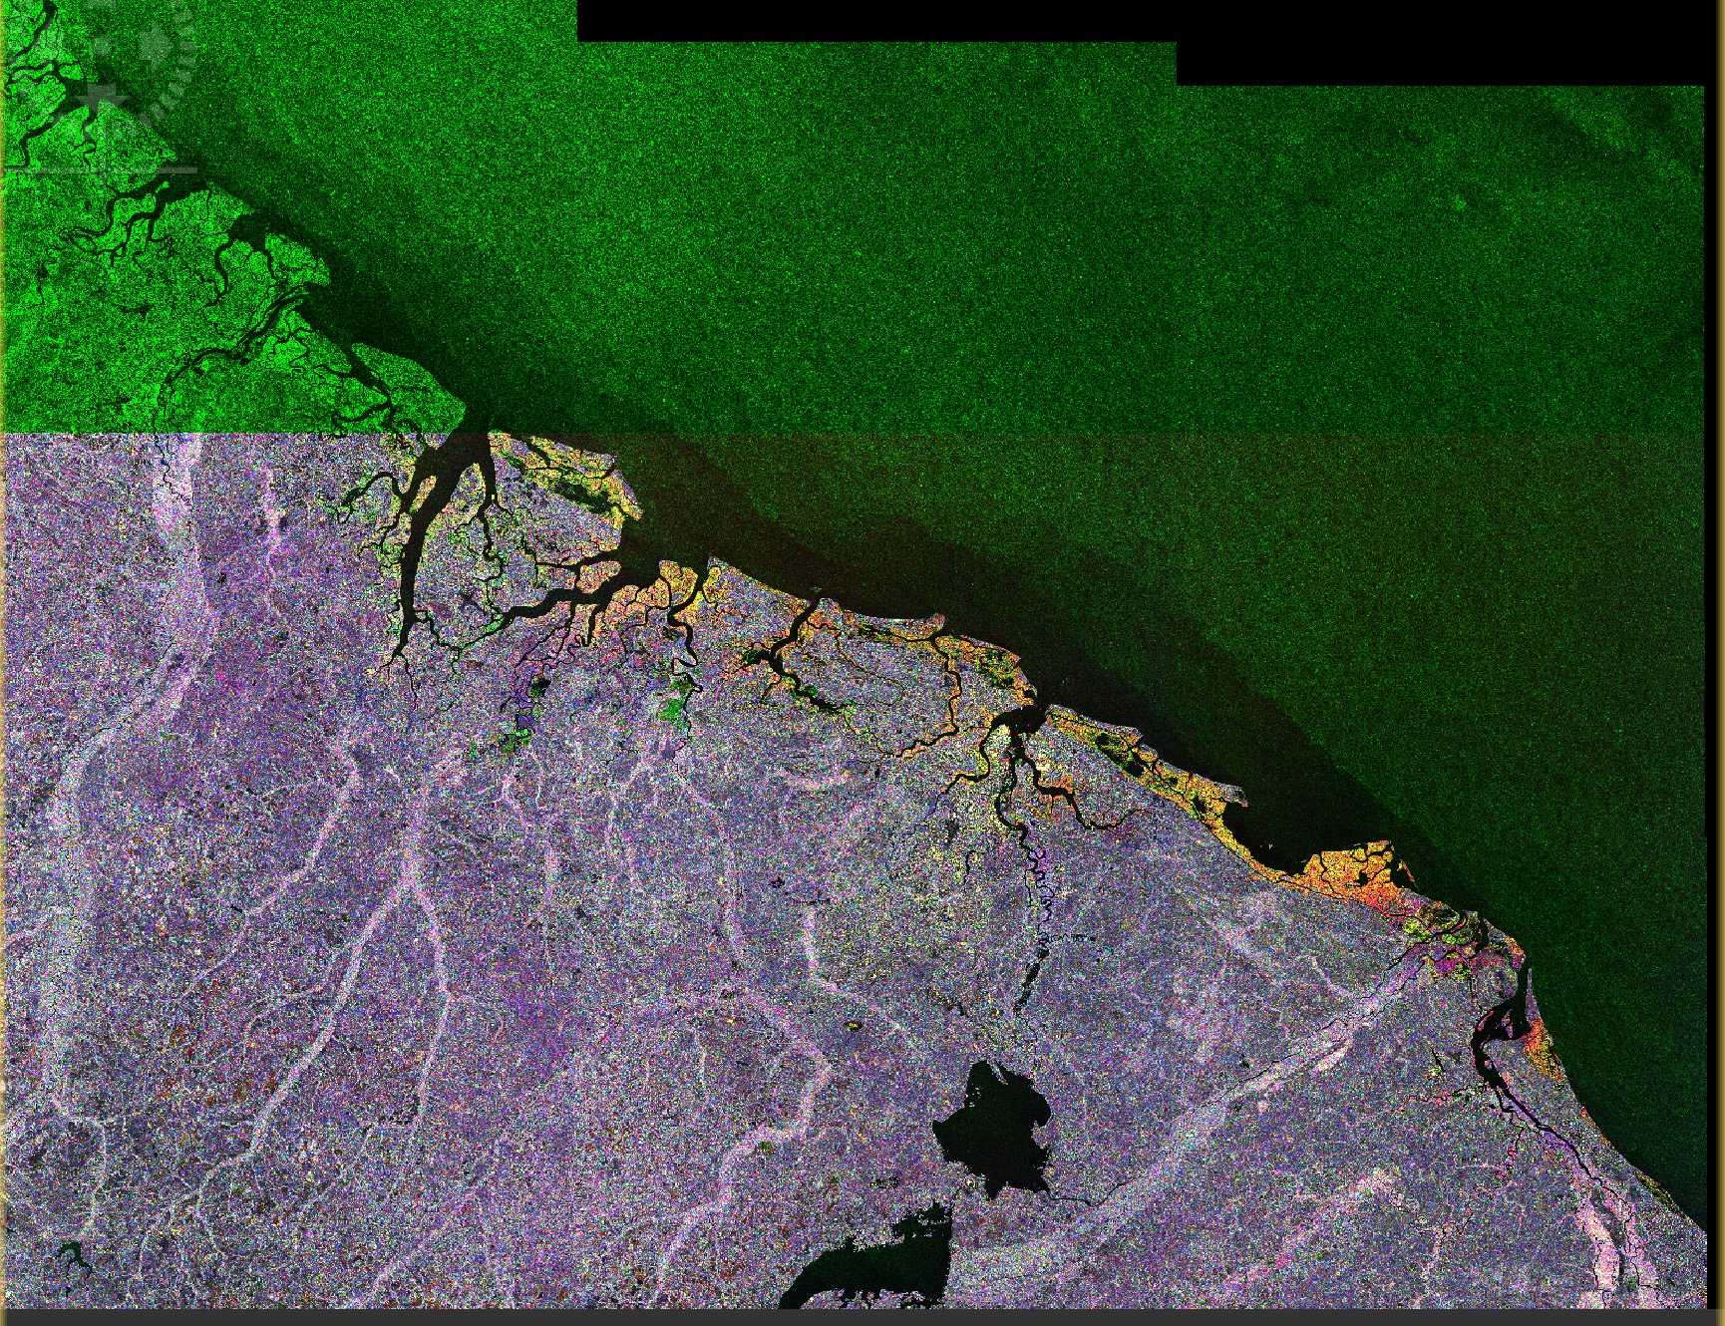
* 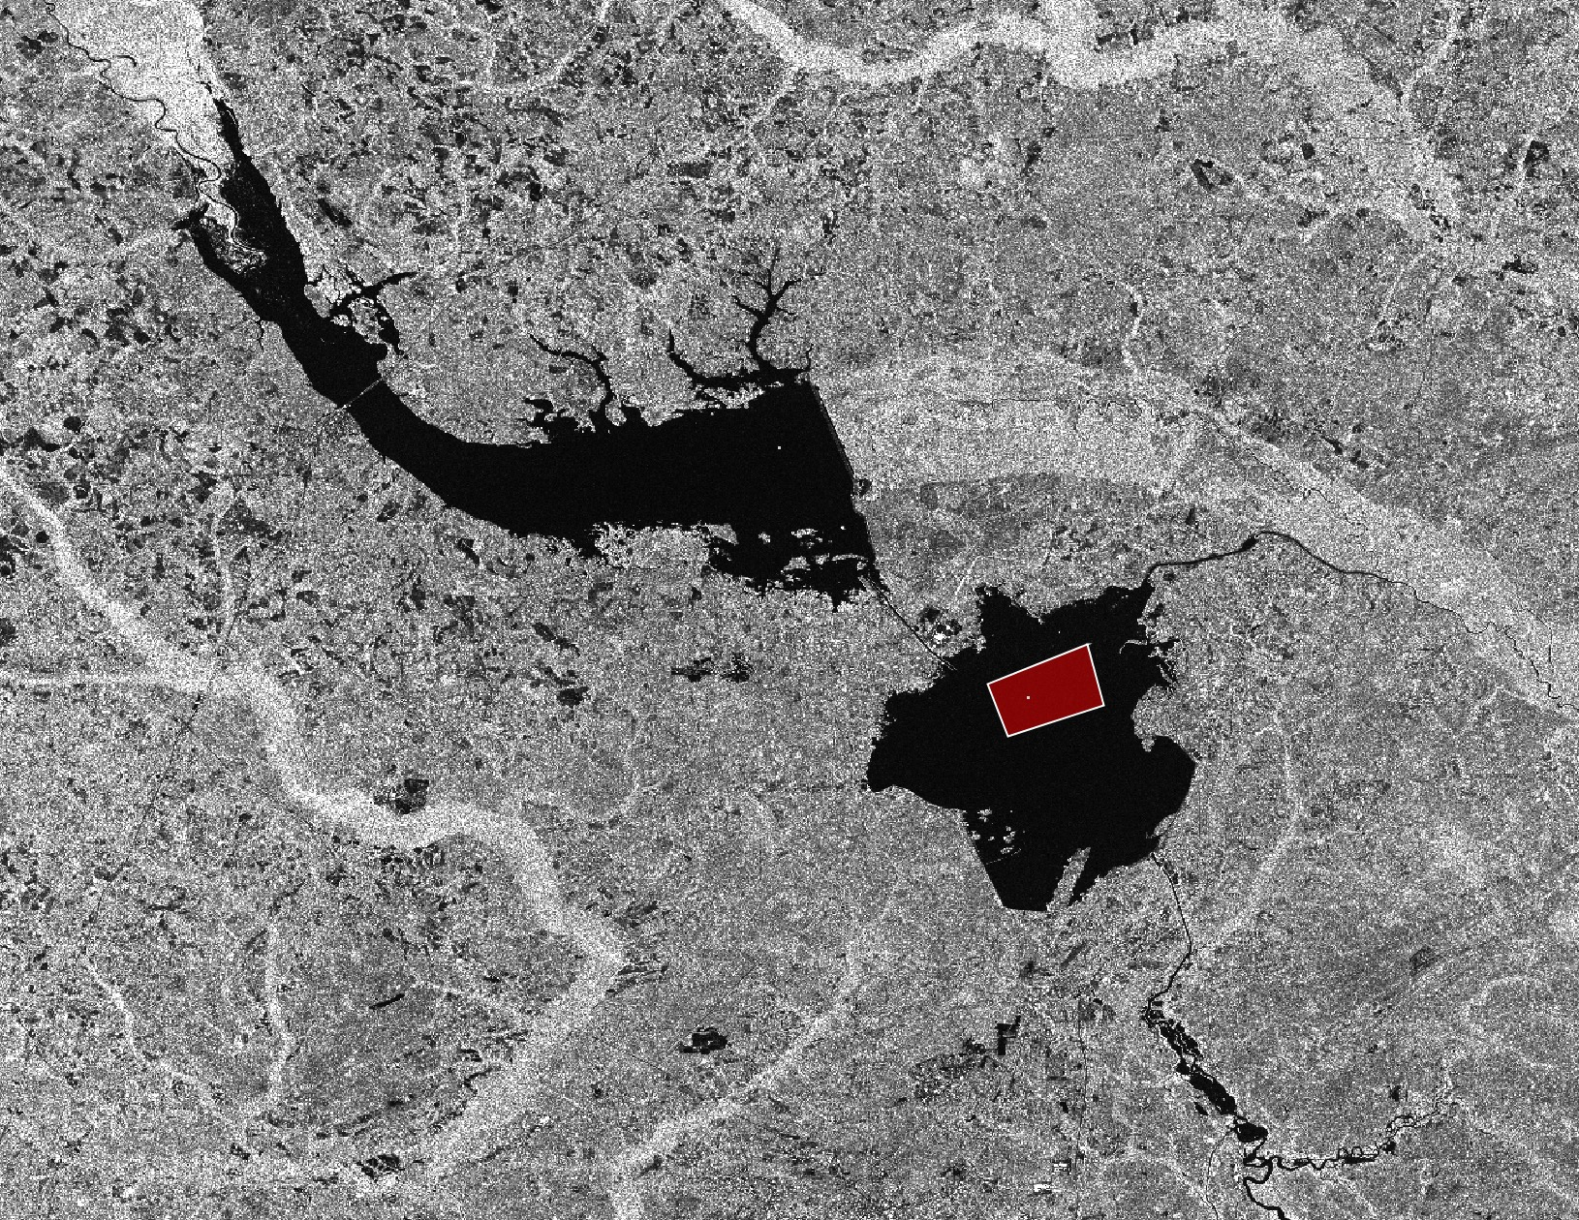Generate a classification by first selecting training areas. In the top menu under **Vector,** select **New Vector Data Container** and provide a name for your training class (in the case open_water)
* In the **Tools** menu along the top bar, select the Polygon Drawing Tool 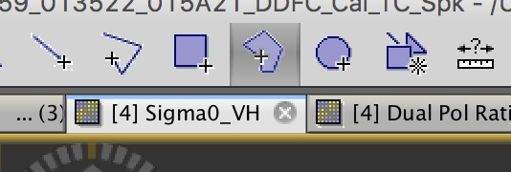
* Create a polygon of the area representative of open water. Do these same steps for each class you want to define.
* Once completed run the **Random Forest Classification** by clicking on **Raster** in the top menu, then **Classification** > **Supervised Classification** > **Radom Forest Classifier**
* In the pop-up window, select the files that you want to use in your classification. To load them, select the **add-opened files** on the column on the right (the second one down). Run it.
* In the image, high flood areas will appear magenta, low flood areas pink, open water blue, and non-flooded areas will be green.
* 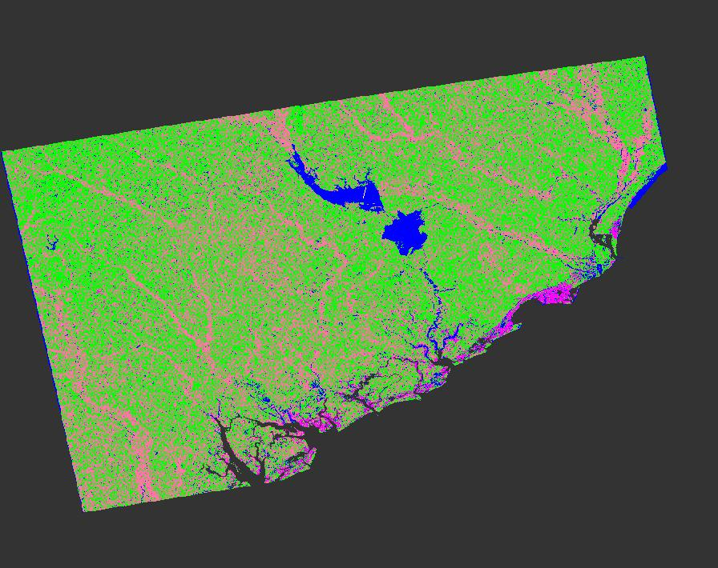You can change the colors on your classification by going to **View** in the top menu, selecting **Tool Windows** > **Colour Manipulation**